Reg. No. CODE: SPH2

PH. D COURSEWORK EXAMINATION, MAY 2023

SUBJECT: COMPUTER SCIENCE AND INFORMATION TECHNOLOGY

SPECIALIZATION PAPER 2 - IMAGE PROCESSING

Time: 03 hours Maximum Marks: 50

Name: B. JayaPrakash

Instructions:
- Section A Compulsory
- Answer any four from Section B
- Each question carries 10 Marks

SECTION A

Answer the following question: (10 Marks)

- For the given 4 x 4 image having a grey scale value between [0,9].
Table:1

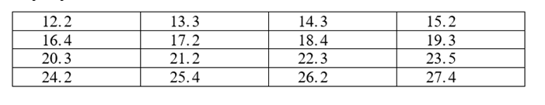
- Find a histogram for equalized image using Table 1.
- Draw the histogram of an image before and after equalization using Table 1.
- Elaborate equalization process and its example.

SECTION B

Answer any four from the following question: (Each carrying 10 Marks)

2. Elaborate RGB, CMY, and HSL color models. Discuss the procedure of converting RGB to HSL colour model and vice versa.

3. Explain about Wiener filter used for image restoration and its example.

4. Briefly explain about the following morphological image processing algorithms and its process
i. Boundary extraction
ii. Region filling.
iii. Convex hull
iv. Thinning and skeletons.

5. Elaborate Deterministic and scholastic-based restoration filters with real time applications.

6. Explain about point, line, edge and thresholding detection in image segmentation process with real time example.

7. Articulate Huffman coding, Arithmetic coding, LZW coding, and JPEG Compression standard.

********

